Name: ____________________________________ Date: ________________
Chapter 9 Lesson 3
Page 352 and 353 Earth’s Structure
- Read the focus skill, keep this in mind when reading this section.
- Read this section as a class.
- While reading, answer the questions below.

- About how many kilometers would you need to dig down to reach the center of the Earth?
___________________________
- What is the outer layer of Earth? What is it made of?
____________________________________________________________________________________________________________________________________________________________________________________________________________________________________________________________________

- What layer is beneath Earth’s crust? What is it made of?
____________________________________________________________________________________________________________________________________________________________________________________________________________________________________________________________________

- What is found in the center of Earth? What is it made of?
____________________________________________________________________________________________________________________________________________________________________________________________________________________________________________________________________
- What are plates?
__________________________________________________________________________________________________________________________________

- What causes Earth’s plates to move?
____________________________________________________________________________________________________________________________________________________________________________________________________________________________________________________________________

Page 354 and 355 Earthquakes
- Read the focus skill. Keep this in mind when reading this section.
- Read the section in partners.
- After reading, answer the questions below.

- What is an earthquake?
___________________________________________________________________________________________________________________________________________________________________________________________________

- What is the difference between the focus and the epicenter?
__________________________________________________________________________________________________________________________________
_________________________________________________________________
- What are the three movements of plates that can cause earthquakes?
__________________________________________________________________________________________________________________________________

- Where might you find a fault?
__________________________________________________________________________________________________________________________________

- Why do faults form?
___________________________________________________________________________________________________________________________________________________________________________________________________

- Why do you think earthquakes formed by plates pulling apart are weaker than those formed by plates pushing together or sliding past each other?
__________________________________________________________________________________________________________________________________
__________________________________________________________________________________________________________________________________

- On the Richter scale, at which magnitude can an earthquake cause a lot of damage?
________________________
Use the captions and pictures on page 355 to help you answer the questions below.
- How many times stronger was the 1964 Alaska earthquake than the 1976 China earthquake?
________________________

- What was the magnitude of the 1979 earthquake in Indonesia?
________________________

- What was the magnitude of the 1933 earthquake in Japan?
________________________

- Which earthquake on the table was the most powerful?
________________________

- Which earthquake on the table was the least powerful?
________________________

Page 356 and 357 Volcanoes
- Read the focus skill. Keep this in mind when reading this section.
- Read the section independently.
- After reading, answer the questions below.

- What is the difference between lava and magma?
___________________________________________________________________________________________________________________________________________________________________________________________________
- How does a volcano form?
___________________________________________________________________________________________________________________________________________________________________________________________________
- What is a hot spot?
___________________________________________________________________________________________________________________________________________________________________________________________________
- What causes a chain of volcanoes to form?
____________________________________________________________________________________________________________________________________________________________________________________________________________________________________________________________________

Label each of the following pictures with Composite Volcano, Shield Volcano, or Cinder Cone Volcano.

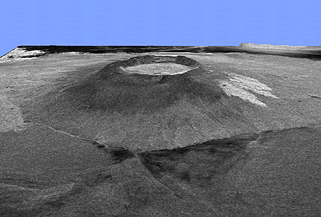 ________________________________
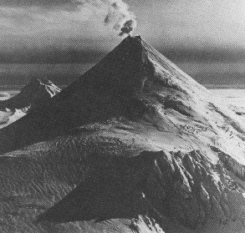 ________________________________
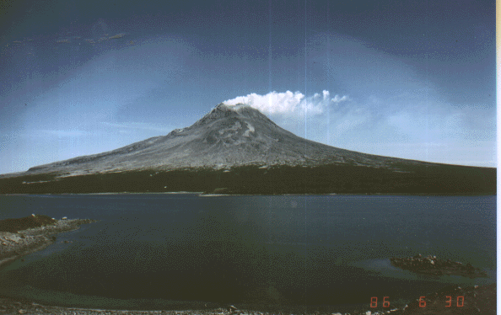 ________________________________

Read each volcano description below. Then write Composite, Shield, or Cinder Cone.
- Broad volcanoes with gentle slopes: ______________________
- Made of rock, ash, and other solid materials from volcanic eruptions: ______________________
- Tall and narrow with steep slopes: ______________________
- Form from lava that flows easily: ______________________
- Made of alternating layers of lava and ash: ______________________
- Wide with fairly steep slopes: ______________________

Page 358 How Mountains Form
- Read the focus skill. Keep this in mind when reading this section.
- Read the section independently.
- After reading, answer the questions below.

- How do mountains form when plates push together?
___________________________________________________________________________________________________________________________________________________________________________________________________
- How do mountains form in the middle of plates?
___________________________________________________________________________________________________________________________________________________________________________________________________
- How do mountains form where plates pull apart?
___________________________________________________________________________________________________________________________________________________________________________________________________
- How might mountains in the center of plates differ in appearance from those along the edges of plates?
____________________________________________________________________________________________________________________________________________________________________________________________________________________________________________________________________

