Name: ____________________________________ Date: ________________
Chapter 7 Lesson 3
Page 286 and 287 Processes that Change Rocks
- Read the focus skill, keep this in mind when reading this section.
- Read this section as a class.
- While reading, answer the questions.

1. Why do rocks weather at different rates?
___________________________________________________________________________________________________________________________________________________________________________________________________
2. What is the difference between weathering and erosion?
____________________________________________________________________________________________________________________________________________________________________________________________________________________________________________________________________
3. What happens to sediment after weathering?
____________________________________________________________________________________________________________________________________________________________________________________________________________________________________________________________________

4. Label the pictures below with the following labels: deposition, weathering, erosion
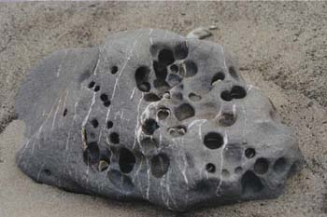 ___________________________
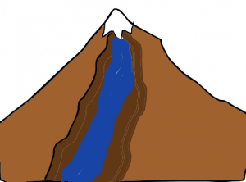 ___________________________
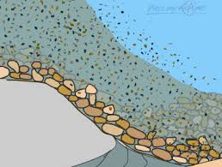 ___________________________
Use the picture on page 286 to help you answer the next two questions.
5. What kind of structure is shown here?
_________________________
6. What kind of rock forms from the melted rock on this structure?
_________________________

7. How might freezing and thawing weather a rock?
____________________________________________________________________________________________________________________________________________________________________________________________________________________________________________________________________
8. What role do rain and wind have in changing one kind of rock into another kind of rock?
___________________________________________________________________________________________________________________________________________________________________________________________________
Label each of the following situations with one of these three processes: weathering, erosion, deposition.
9. Sediment is dropped by the wind into a valley. _____________________
10. The heat of the sun causes limestone to crack and small pieces flake off. _____________________
11. Windblown dust slowly scratches off pieces of gneiss. _____________________
12. A piece of marble is picked up by the wind. _____________________
13. A small piece of sandstone is washed up on a beach. _____________________
14. A piece of pumice floats down a river. _____________________
Page 288 and 289 The Rock Cycle
- Read the focus skill. Keep this in mind when reading this section.
- Read the section independently.
- After reading, answer the questions below.

15. What is the rock cycle?
___________________________________________________________________________________________________________________________________________________________________________________________________

Write I (igneous), S (sedimentary), or M (metamorphic) for the new rock formed in each of the following situations.

16. _____ Sandstone, a sedimentary rock turns into gneiss by receiving a great amount of heat and pressure.

17. _____Gneiss, a metamorphic rock, can be weathered, eroded, deposited, and then cemented into a new type of rock.

18. _____When sandstone, a sedimentary rock, is melted, it hardens and forms a new rock when it cools.

19. _____ When granite, an igneous rock, changes into a new rock through weathering and erosion.

20. _____ When granite, an igneous rock, is melted and hardens.

21. _____ When a metamorphic rock is melted and then hardens again.

22. _____ When granite, an igneous rock receives heat and pressure.

23. _____ When gneiss, a metamorphic rock is subjected to a great amount of heat and pressure.

24. _____ When sandstone, a sedimentary rock is weathered and eroded.

25. Which types of rock can an igneous rock turn into?

__________________________________________________________________________________________________________________________________
26. Which types of rock can a metamorphic rock turn into?

__________________________________________________________________________________________________________________________________
27. Which types of rock can a sedimentary rock turn into?
__________________________________________________________________________________________________________________________________

Page 290 Soil Formation
- Read the focus skill. Keep this in mind when reading this section.
- Read the section with your partner.
- After reading, answer the questions below.

28. Name three differences soil can have.
____________________________________________________________________________________________________________________________________________________________________________________________________________________________________________________________________
29. What is one similarity that all soil must have?
__________________________________________________________________________________________________________________________________
30. What determines the types of minerals found in soil?
____________________________________________________________________________________________________________________________________________________________________________________________________________________________________________________________________
31. Why is humus important for plant growth?
___________________________________________________________________________________________________________________________________________________________________________________________________

32. Which layer of soil contains the largest chunks of rock?
_____________________________
33. Which layer of soil contains the most humus? _____________________________
34. Which layer of soil do you think would be the most fertile? Explain your answer.
____________________________________________________________________________________________________________________________________________________________________________________________________________________________________________________________________
35. What must happen first for soil to form?
___________________________________________________________________________________________________________________________________________________________________________________________________

